# ISLAMIC UNIVERSITY OF TECHNOLOGY

# Organization of Islamic Cooperation

# Board Bazar, Gazipur

# Lab 01

# Study of Diode Characteristics and its Applications using PSIM

# EEE 4484

**Task 1**

Circuit Diagram



V-I Characteristics Table

|  |  |  |
| --- | --- | --- |
| DC Voltage Source ($V$) | Diode Voltage ($V$) | Diode Current ($mA$) |
| $$0.1$$ | $$0.099$$ | $$1×{10}^{-5}$$ |
| $$0.3$$ | $$0.299$$ | $$3×{10}^{-5}$$ |
| $$0.5$$ | $$0.499$$ | $$5×{10}^{-5}$$ |
| $$0.6$$ | $$0.599$$ | $$6×{10}^{-5}$$ |
| $$0.7$$ | $$0.699$$ | $$7×{10}^{-5}$$ |
| $$1$$ | $$0.7$$ | $$0.3$$ |
| $$3$$ | $$0.7$$ | $$2.3$$ |
| $$5$$ | $$0.7$$ | $$4.3$$ |

V-I Characteristics Graph



**Task 2**

Circuit Diagram



Wave Shapes

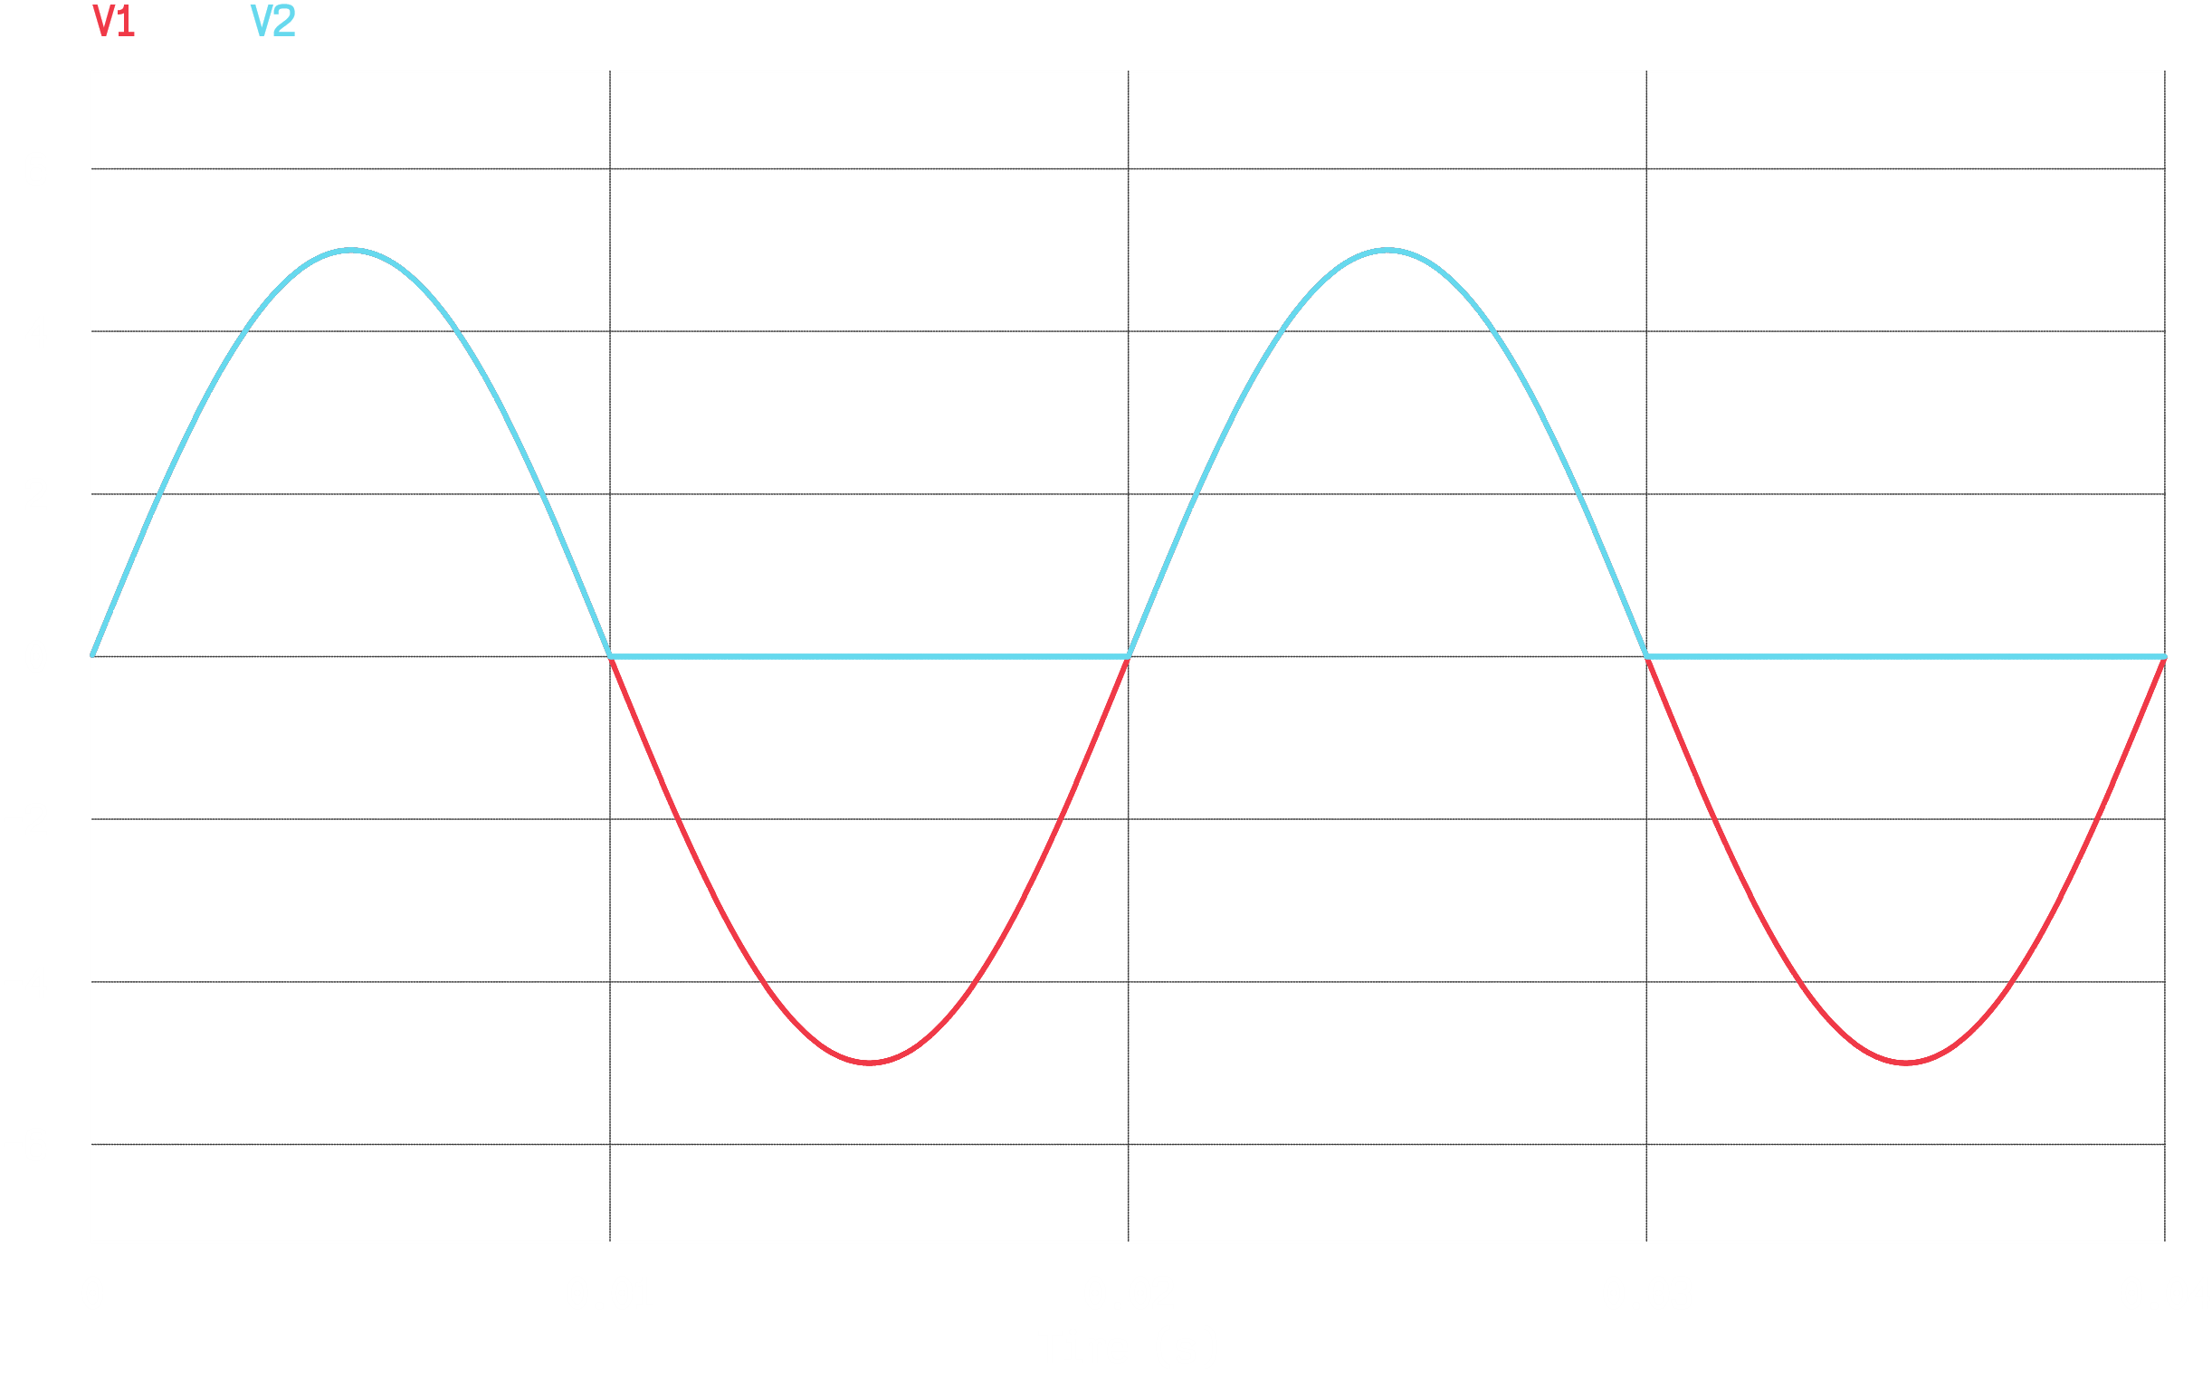

**Task 3**

Circuit Diagram



Wave Shapes

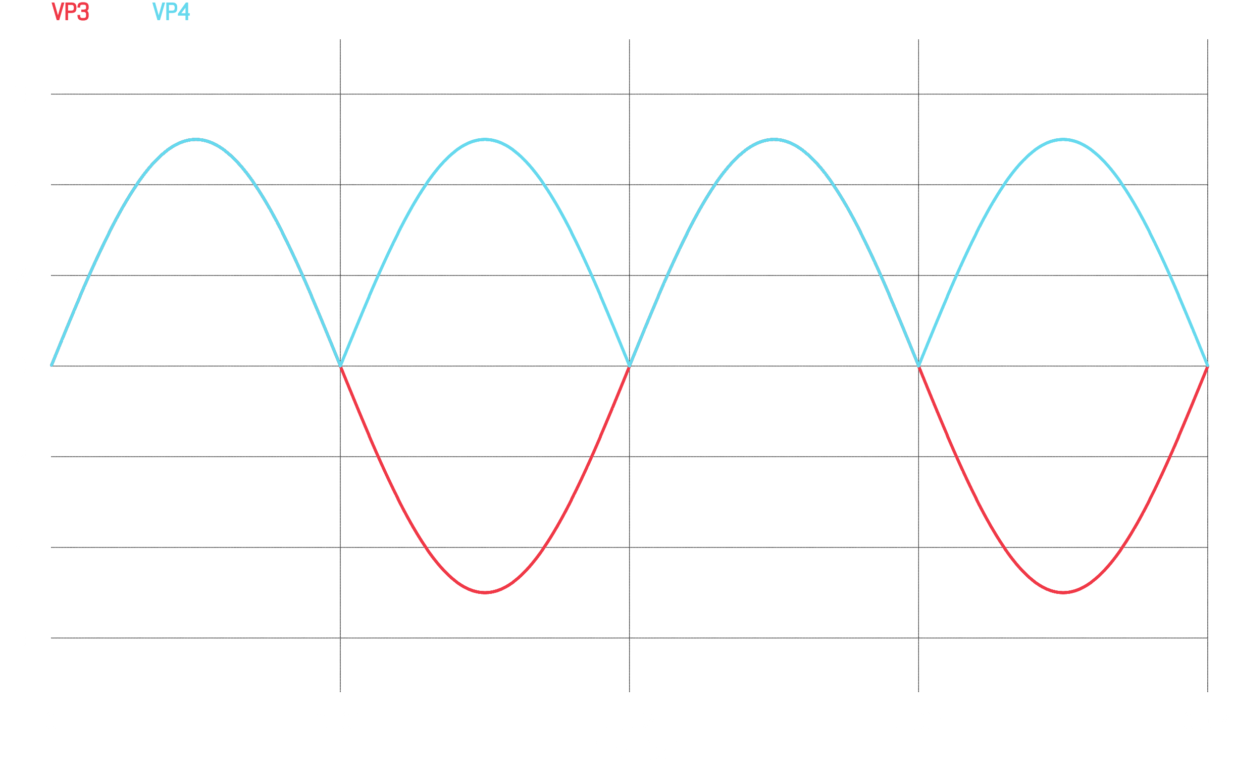

**Assignment**

2.

Circuit Diagram



Wave Shapes

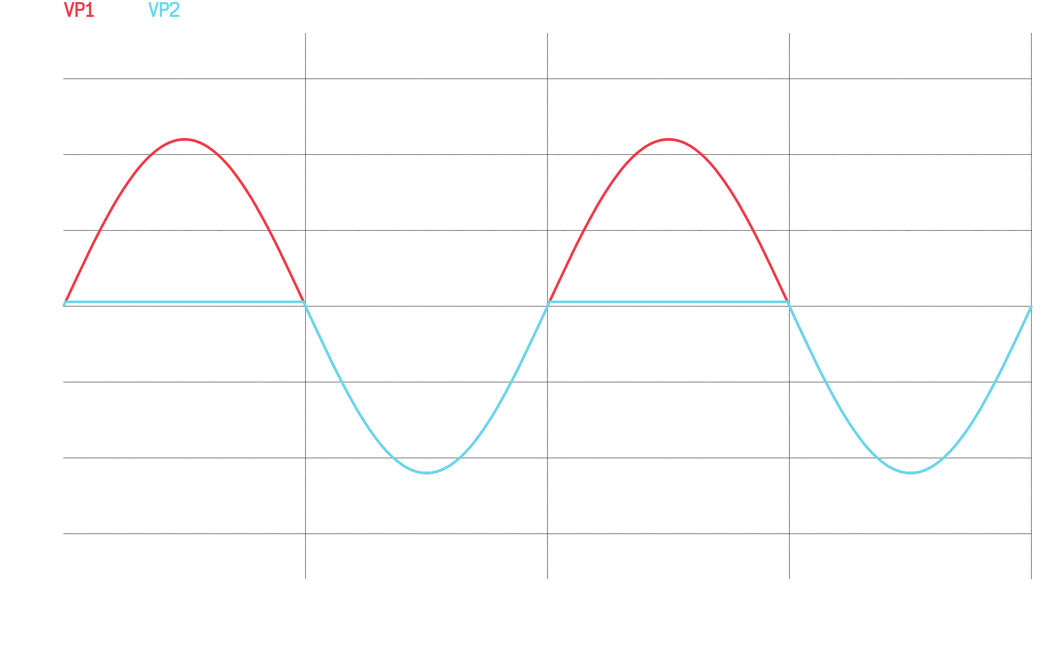

3.

Circuit Diagram



From PSIM, $I=-5.31×{10}^{-5}mA$ and $V=-1.23V$.

Applying KVL to the loop on the left,

$$3=12i_{i}$$

$$i_{1}=0.25mA$$

Applying KVL to the loop on the right,

$$3=6i_{2}$$

$$i_{2}=0.5mA$$

$$∴I=i_{i}-i_{2}=0.25-0.5=-0.25mA$$

Theoretically, this should be the answer. However, due to the existence of the diode, this current cannot pass, since the orientation of the diode does not allow current to pass in this direction. As such, there should be some extremely small reverse saturation current. This is the value that we get from the PSIM simulation.

Due to the fact that $D_{1}$ is not conducting, we can effectively ignore that path. Thus,

$$3+3-0.7=\left(12+6\right)×1000×I$$

$$I=0.294mA$$

$$V=-3+6(0.294)$$

$$=-1.23V$$

4.

Circuit Diagram



Wave Shapes

